A Recipe For:

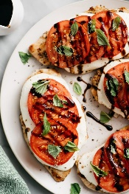 

# Caprese Chicken

**From the Kitchen of:** Michelle

**Servings:** 4

**Prep Time:** 35 minutes **Bake Time:** **Bake Temp:** Grill

**Ingredients:**

* 4 chicken breasts
* 1 cup balsamic vinaigrette
* 3 Tbsp honey
* 2 Tbsp avocado oil
* Dash of salt
* Dash of pepper
* Chicken rub
* Fresh tomato and basil
* Sliced mozzarella cheese
* Balsamic glaze

Combine first seven ingredients and marinade chicken for a few hours. Grill chicken. Melt mozzarella on top of grilled chicken. Top with fresh basil, tomato and the glaze.